HILLY FIELDS FOOTBALL CLUB
SEASON 21: 1987-88
FIRST TEAM:
BECKENHAM & CATFORD ALLIANCE:
P W D L F A Pts Pos
Division 1 16 11 0 5 39 17 22 4th
Beckenham League Cup 1 0 0 1 1 3
Beckenham Hospital Cup 1 0 0 1 0 8
Hither Green Hospital Cup 1 0 0 1 0 3
Tom Betton Invitation 2 1 0 1 5 4
Friendly 5 3 1 1 15 9
TOTAL 26 15 1 10 60 44
Apps Gls Apps Gls
Dean Chatfield 24 21 Mark Rumbelow 21 0
Mick Chatfield 23 2 Nick Rumbelow 14 2
John Coles 19 2 Gavin Phipps 4 0
Mark Falconer 1 0 Costas Salacuri 1 0
Steve Ford 24 9 Tommy Salacuri 25 0
Keith Foster 2 0 Kevin Shearer 24 5
Larry Garnham 1 0 Charlie Shoppee 22 0
James Greet 16 6 Mark Thompson 20 1
Dave Keay 20 1 John Wood 22 1
Mike Kiely 3 0 Chris Yusuf 14 4
Kevin McCormick 7 0 OG 6
Adam Mosley 2 0

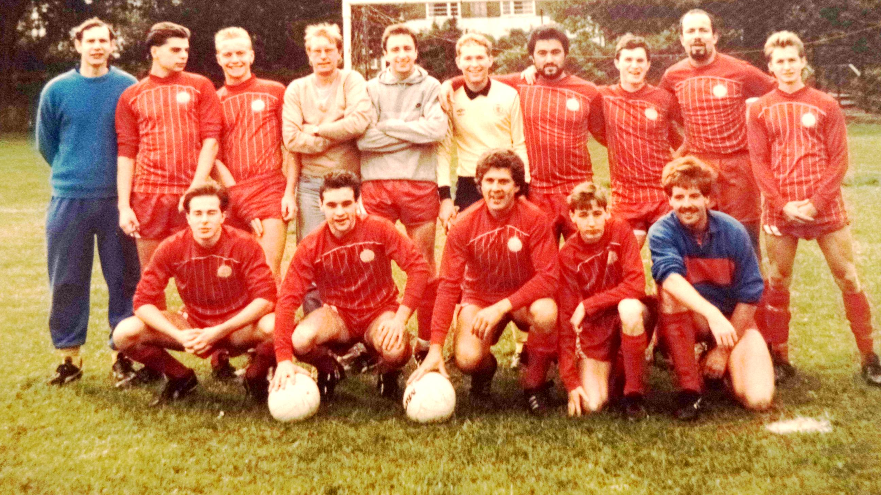
L-R Back: Keith Foster, Mark Rumbelow, Gavin Phipps, Larry Garnham, John Wood, Kevin McCormick, Tommy Salacuri, Mick Chatfield, Chris Yusuf, Steve Ford L-R Front: James Greet, Dean Chatfield, Kevin Shearer, John Coles, Dave Keay

